**Regular Ensaymada**

<https://www.spot.ph/i-think-therefore-i-ham/72231/ensaymada-panaderia-philippine-bread-a209-20171205-lfrm2>

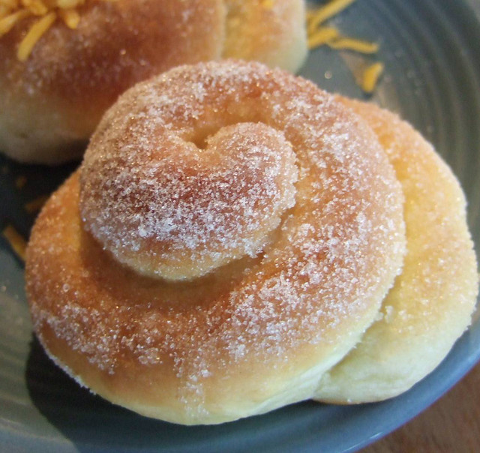

Ensaymada is a Filipino sweet pastry. This is said to be a variation of the Ensaimades, a similar bread that uses pork lard as an ingredient that originated in Majorca (the largest island of Spain).

Our regular ensaymada is a sweet bread usually eaten partnered with coffee. This is usually enjoyed as a mid-afternoon snack. Our regular ensaymada is topped with sugar.

**Pandesal**

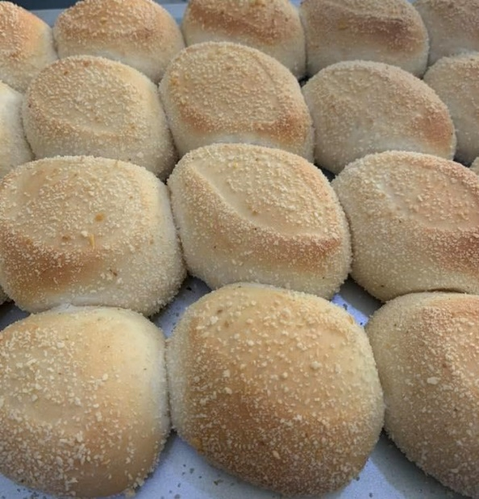

Pandesal means “bread of salt” in Spanish, for the pinch of salt added to the dough. It was introduced to the Philippines in the 16th century as the Spaniards' answer to the French baguette. It is probably the most popular bread in the Philippines. Pandesal is the favorite breakfast food of most Filipinos.

Our pandesal is slightly sweet and salty, soft and fluffy white bread roll that is amazingly tasty. It’s best served warm fresh from the oven.

**Spanish Bread**

**facebook.com/cuevasbakeshopaustralia/photos/a.526994354049664/2929019277180481/?type=3&theater**

<https://www.reddit.com/r/food/comments/ap71ek/homemade_filipino_spanish_bread/>

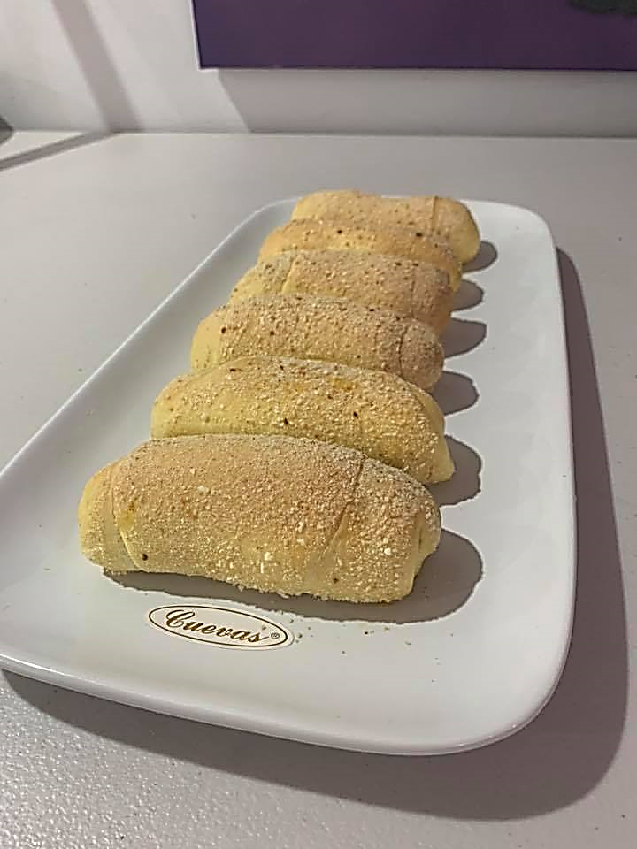

Spanish Bread are soft bread rolls that are filled with a sweet, buttery paste, dusted with bread crumbs and baked to golden perfection. Filipino Spanish Bread is a popular ‘merienda’ or afternoon snack in the Philippines. It has nothing to do with the Spanish bread of Spain(Pan de Horno) except maybe that they share the same form (rolled) but the Filipino version of Spanish bread has a sweet buttery filling in it.

Our Spanish bread is soft and fluffy filled with butter and sugar then laid in breadcrumbs. Like our other breads, this will definitely be every Filipino’s favorite merienda.

**Cheese Bread**

<https://www.womanscribbles.net/sweet-cheese-rolls/>

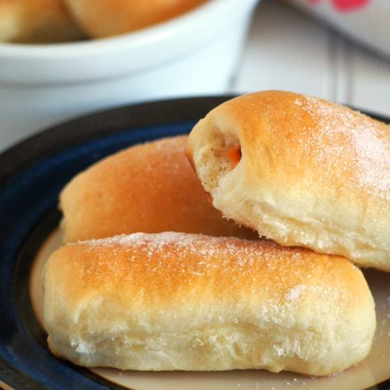

This soft buttery yeasted bread has cheese filling. Ultra soft bread gets filled with melty cheese inside. You will love this sweet cheese rolls for your snack, breakfast or dessert. These cheese rolls are with melty cheese inside the soft, sweet bread, making your coffee (or hot chocolate) time more comforting. Another well-loved breakfast or afternoon snack by many Filipinos! Unlike other cheese bread you know, Filipino cheese bread is sweet and milky.

**Pan de Coco**

**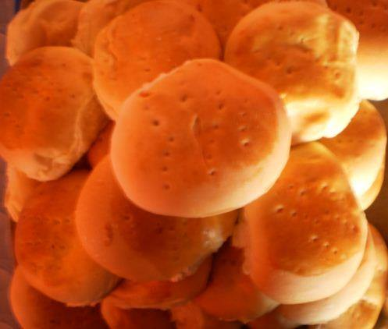**

Pan de Coco is one of our favorite traditional Filipino bread, usually bought for merienda (afternoon snack) or breakfast. This yummy soft roll filled with sweet desiccated coconut that is a hit with the kids. You can enjoy eating this sweet bread with coffee or any cold drinks.

**MONAY**

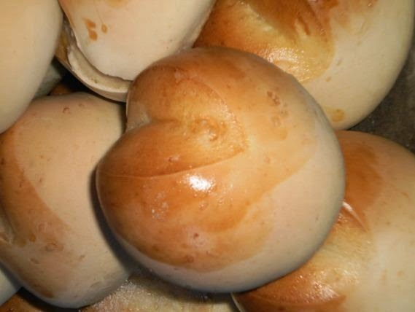

<https://www.cookingpinoy.com/filipino-monay-bread-recipe/>

Monay is a dense bread roll from the Philippines made with all-purpose flour, milk, and salt. It has a characteristic shape, with an indentation down the middle dividing the bread into two round halves.

**PUTOK**

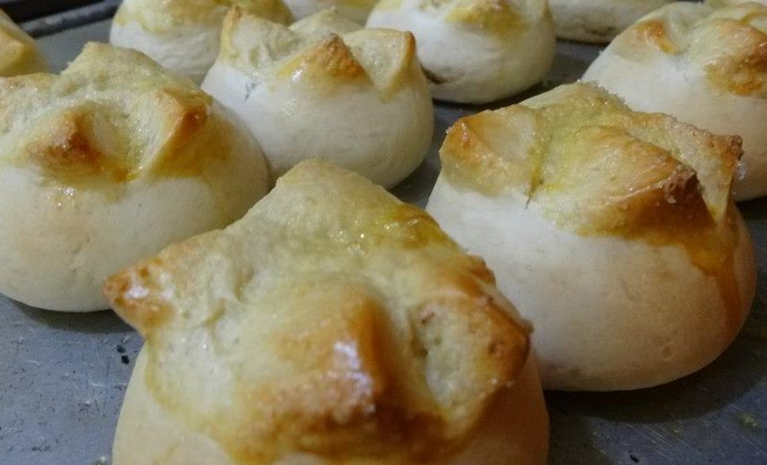

Star Bread or Putok with its trademark crack on top, which looks like it has exploded. A sweet bun with sugar sprinkled on top that has a shiny crust, a bit hard outside but soft inside. A favorite snack in the Philippines that you and your family will enjoy too!

Putok is a Filipino word that translates to “explosion” or “fissure” achieved from a cross-shaped cut on the dough prior to baking. This dense bread from the Philippines made with flour, milk, and salt is an offshoot from the standard monay dough.

**Special Ensaymada**

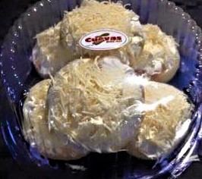

Who could resist our special ensaymada which is soft and buttery sweet dough that is baked to become pillowy buns and specially coated with buttercream frosting and topped with lots of grated cheese. This is a perfect mate for your coffee and tea. We are sure, one piece will never be enough for each individual.

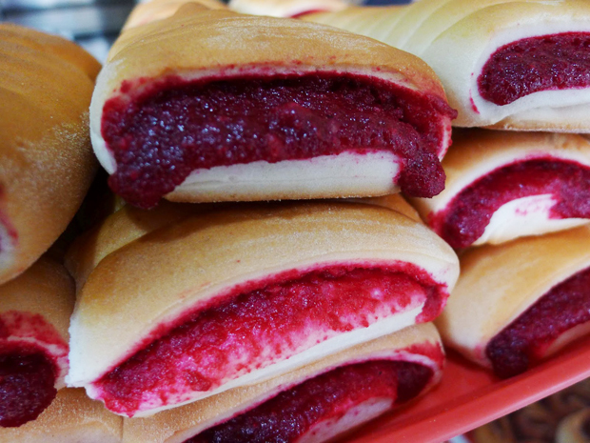

<https://store7398264.ecwid.com/Pan-de-Regla-p53828263>

Pan de Regla is a Filipino bread that's also known as  Pan de Pula, or Kabukiran. It's a soft bread commonly found in most Pinoy bakeries and has pockets stuffed with a red-colored pudding made with flour (or stale bread), milk, sugar, butter, or margarine, and of course, red food coloring. This easy recipe includes a filling made with all-purpose flour so you don't need to prep days ahead for the pudding.

**EGG PIE**

<https://www.google.com/search?q=eggpie&tbm=isch&chips=q:egg+pie,g_1:filipino:7L6N2tdpxeo%3D&hl=en&ved=2ahUKEwiDksnOqvDoAhWWEKYKHccRD64Q4lYoAHoECAEQFQ&biw=1349&bih=657#imgrc=QR1A-f0txds4EM&imgdii=vEE5pDtN7gRRrM>

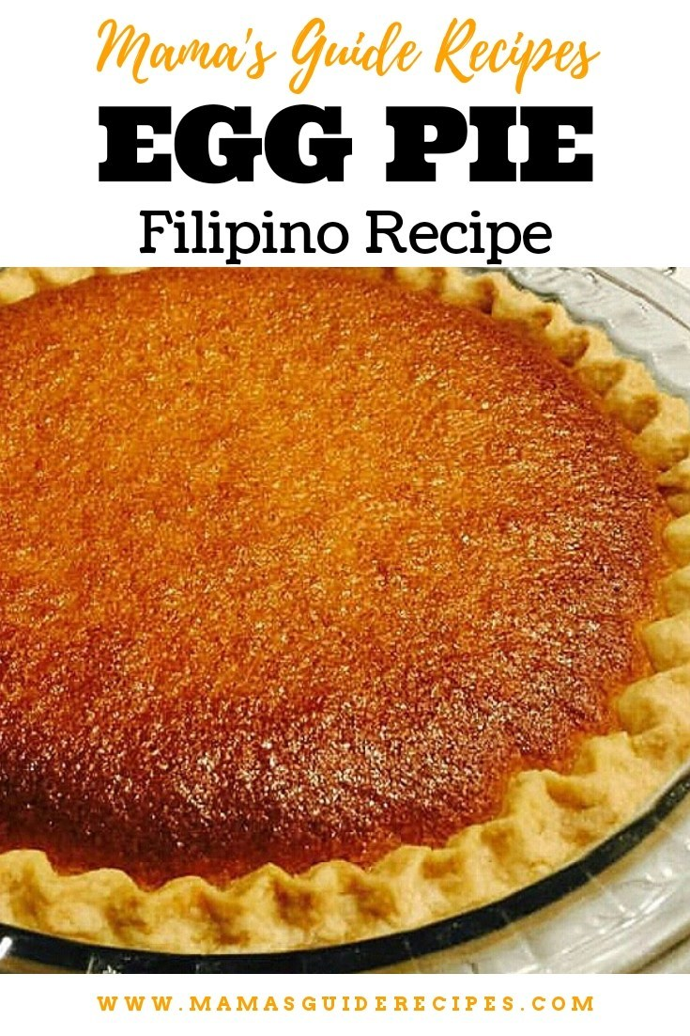

The egg pie with a very rich egg custard filling is a mainstay in our bakeshop. It is typically baked so that the exposed custard on top is browned.  Though a bit pricier than most of the breads and pastries sold in the bakeshop, Filipinos cannot resist the soft, creamy filling that melts on ones tongue and mouth, and makes for a tasty snack or dessert.

**PIANONO**

**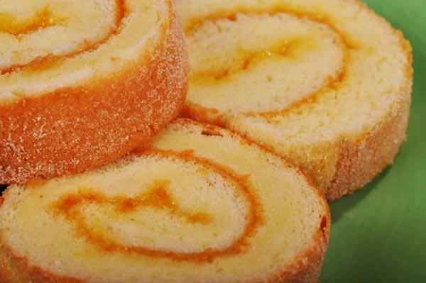**

Pianono bread is similar to its Spanish and South American counterparts wherein bread or pastry dough is rolled around various fillings. It is popular [in countries that were invaded by Spain](https://en.wikipedia.org/wiki/Pionono) such as Philippines, Puerto Rico, Cuba and other parts of South America. The name came from the Italian name of [Pope Pius IX](https://en.wikipedia.org/wiki/Pope_Pius_IX) which is “Pio Nono” meaning “Pious Nine”.

The Filipino-style Pianono is a type of jelly roll consisting of a soft, pillowy sponge cake wrapped around a mixture of margarine and sugar.

**CAKES**

**BRAZO DE MERCEDES**

<https://lovers.coffee/brazo-de-mercedes-recipe/>

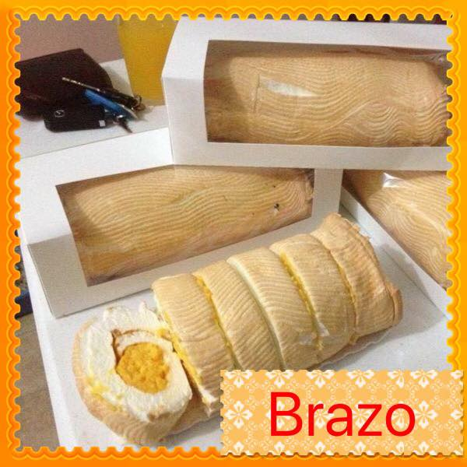

Brazo de Mercedes is a type of rolled cake (sometimes referred to as jelly roll) made from a sheet of soft meringue with [custard](https://panlasangpinoy.com/2010/01/07/filipino-asian-dessert-food-leche-flancustard-cake-recipe/) filling. This heavenly cake can be considered as one of the all-time favorites in the Philippines and a delightful treat during special occasions. It is best served cold and is a Filipino favorite because of its soft, heavenly texture.

Our Brazo de Mercedes is most loved for the sponge-like texture of the meringue that literally melts in your mouth. This is a truly soft and creamy dessert as no flour is used in its creation. It is a rolled cake or jelly roll with the light flavor of the meringue is mixed by the flavor of the rich custard filling.

**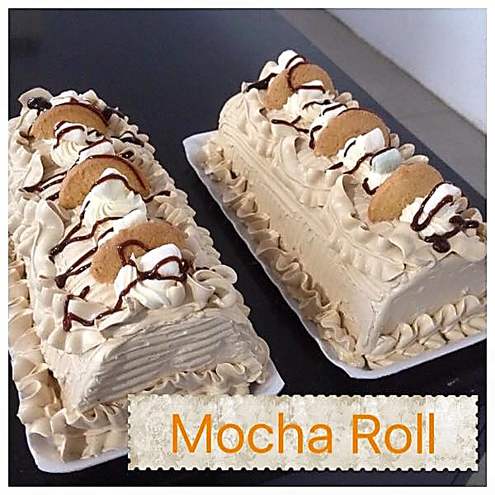Mocha Cake**

The mocha roll is a fluffy and flavorful espresso sponge rolled with a chocolate and espresso whipped cream. This roll will make a perfect way to perk up your day.

Our mocha roll is a moist mocha sponge cake iced in mocha butter crème and chocolate syrup.

**Custard C**

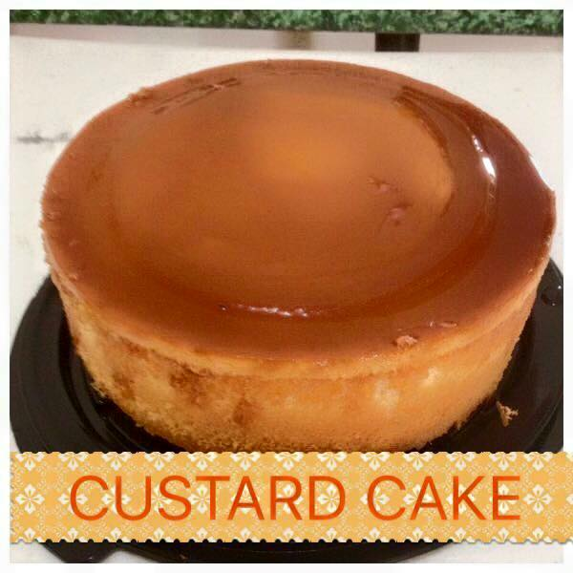

Custard Cake resembles a chiffon cake with a topping of sweetened milk and egg mixture known as custard.

The topping of this cake is definitely leche flan and the only distinction is the soft custard cake.

Our sponge cake is topped with custard glazed with caramelized sugar. It is also an upside-down cake. Before it goes into the oven, the bottom layer consists of the caramelized sugar, the top layer is the sponge cake batter and the uncooked custard is sandwiched in between. After baking, the sides are loosened and the cake is inverted on a plate.

**UBE MACAPUNO CAKE**

**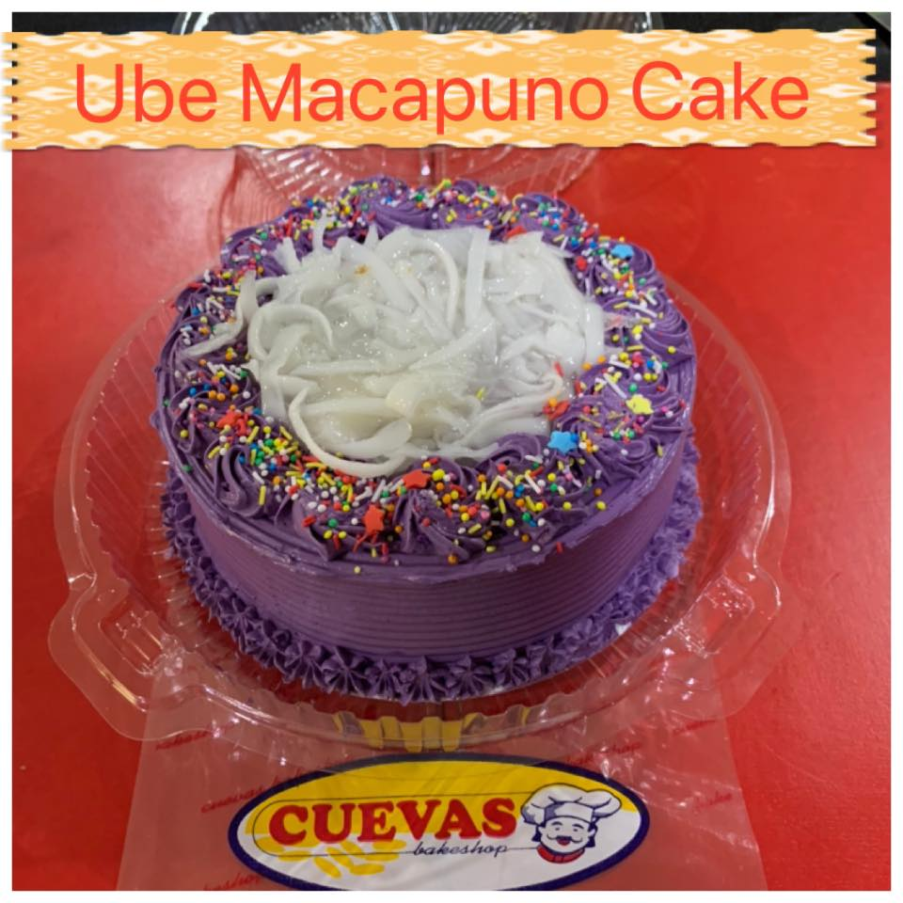**

Ube macapuno cake or purple yam and young coconut sport cake is a sponge cake made out of [purple yam](https://en.wikipedia.org/wiki/Dioscorea_alata) and [macapuno](https://wiki.answers.com/Q/What_is_macapuno" \t "_blank). It is easily distinguished due to its vibrant violet colour. A very popular cake in Philippines where it is available in almost all bakeshops. A really good cake with a very soft texture and mildly sweet and creamy flavour due to the macapuno. Give it a shot if you haven’t tried it yet and you’ll be surprised how irresistible this yam cake brings.

**UBE ROLL**

**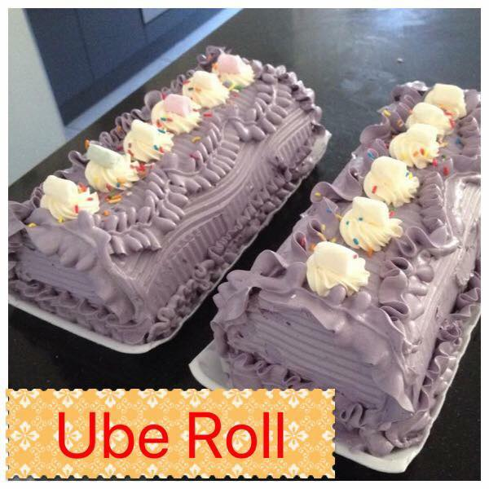**

Ube Cake Roll is made of a soft ube flavored chiffon cake rolled and filled with ube whipped cream. It is a simple, heavenly ube cake dream!  This ube roll is so lovely in its purple color, this cake is so light because it is a chiffon. One where the egg whites are beaten separately to yield the lightest, delicate texture.

**YEMA CUP CAKES**

**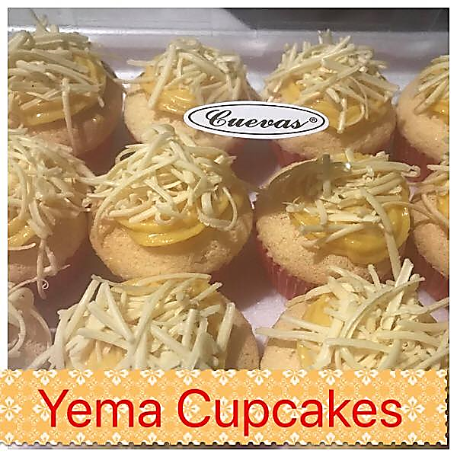**

The cup cakes are topped with a luscious yema frosting and cheese is sprinkled on top. This is one of of our best love cupcake. I f you love yema..this is awesomely delish!

**YEMA CAKE**

**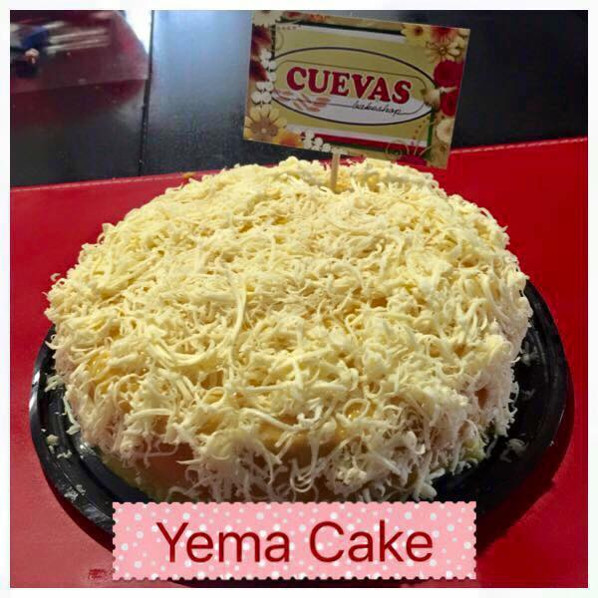**

Yema cake is a Filipino chiffon cake with a custard filling known as yema. It is generally prepared identically to mamón, with the only difference being that it incorporates yema either as frosting, as filling, or as part of the cake batter. Yema is a custard-like combination of milk and egg yolks.

**CINNAMON ROLL**

**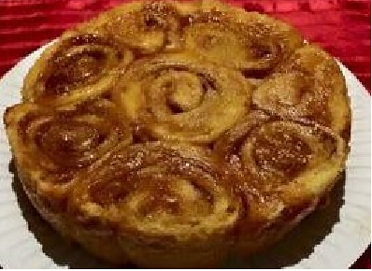**

Each cinnamon roll is extra soft with the most delicious cinnamon swirl! They’re fluffy, soft, and topped with vanilla glaze. These cinnamon rolls are completely irresistible.  If you’re looking for that perfect cinnamon roll, then this is for you.